**Exceptions are a difficult part of MIPs to understand.**

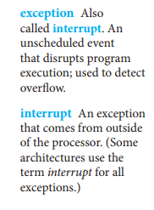

They define the type of interrupt by determining the origin of where the interrupt was initiated; for instance, whether it was from an internal or external source.

